UNITED STATES

SECURITIES AND EXCHANGE COMMISSION
Washington, D.C. 20549

SCHEDULE 14A

Proxy Statement Pursuant to Section 14(a) of the Securities Exchange Act of 1934 (Amendment No.)

Filed by the Registrant ☒ Filed by a Party other than the Registrant ☐

Check the appropriate box:

- Preliminary Proxy Statement

- Confidential, for Use of the Commission Only (as permitted by Rule 14a-6(e)(2))

- Definitive Proxy Statement

- Definitive Additional Materials

- Soliciting Material Under §240.14a-12

Kirby Corporation

(Name of Registrant as Specified in its Charter)

(Name of Person(s) Filing Proxy Statement, if other than the Registrant)

Payment of Filing Fee (Check all boxes that apply):

- No fee required

- Fee paid previously with preliminary materials

- Fee computed on table in exhibit required by Item 25(b) per Exchange Act Rules 14a-6(i)(1) and 0-11


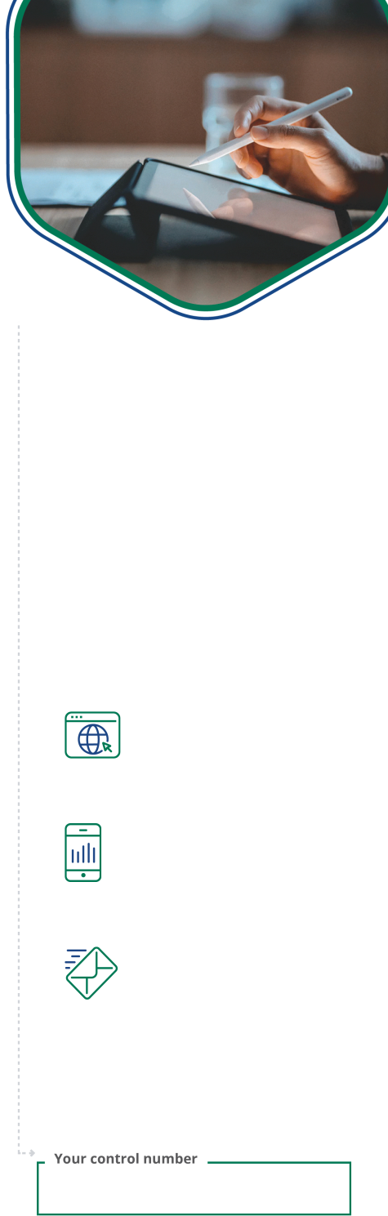
P.O. BOX 8016, CARY, NC 27512-9903

Your vote

matters!

Kirby Corporation

Annual Meeting of Stockholders

Monday, April 27, 2026 10:00 AM, Central Daylight Time 55 Waugh Drive, Suite 1100 Houston, TX 77007

For a convenient way to view proxy materials, including the Notice of the 2026 Annual Meeting, Proxy Statement and the Company's Annual Report, VOTE, and obtain directions to attend the meeting go to www.proxydocs.com/KEX.

To vote your proxy while visiting this site, you will need the 12 digit control number in the box below.

Important Notice Regarding the Availability of Proxy Materials for the Stockholders Meeting to be held on April 27, 2026 For Stockholders of record as of March 2, 2026

To order paper materials, use one of the following methods.

Internet:

www.investorelections.com/KEX

Call:

1-866-648-8133

This communication presents only an overview of the more complete proxy materials that are available to you on the Internet. This is not a ballot. You cannot use this notice to vote your shares. We encourage you to access and review all of the important information contained in the proxy materials before voting.

Email:

paper@investorelections.com

Under United States Securities and Exchange Commission rules, proxy materials do not | * If requesting material by e-mail, please send a blank e-mail with
have to be delivered in paper. Proxy materials can be distributed by making them | the 12 digit control number (located below) in the subject line. No
available on the internet. | other requests, instructions OR other inquiries should be included
available on the internet. | with your e-mail requesting material.
If you want to receive a paper or e-mail copy of the proxy materials, you must request
one. There is no charge to you for requesting a copy. In order to receive a paper
package in time for this year's meeting, you must make this request on or before April
17, 2026.
 | Have the 12 digit control number located in the box above
 | available when you access the website and follow the
 | instructions.
SEE REVERSE SIDE FOR FULL AGENDA

Copyright © 2026 BetaNXT, Inc. or its affiliates. All Rights Reserved

Kirby Corporation Annual Meeting of Stockholders

THE BOARD OF DIRECTORS RECOMMENDS A VOTE:

FOR ON PROPOSALS 1, 2, 3, 4 AND 5

PROPOSAL

- Election of three Class I directors 1.01 Richard J. Alario
1.02 Tracy A. Embree

1.03 David W. Grzebinski

- Ratification of the Audit Committee's selection of KPMG LLP as Kirby's independent registered public accounting firm for 2026

- Advisory vote on the approval of the compensation of Kirby's named executive officers

- Approval of Amendment of the 2005 Stock and Incentive Plan

- Approval of Amendment of the 2000 Nonemployee Director Stock Plan

